HOSPITAL ANALYTICS SYSTEM
ID: [Your Register Number]
Name: [Your Name]
College: [Your College Name]
GitHub URL: To be added

Project Overview
The Hospital Analytics System is a relational database project built to analyze patient visits, doctor performance, and revenue trends across a multi-department hospital. It models the end-to-end patient journey — appointment booking, OPD/IPD/Emergency visits, diagnosis, treatment, prescriptions, lab tests, admissions, billing, payments, and patient feedback — across 15 interconnected tables.
The project includes 47 SQL queries organized into Basic, Intermediate, and Advanced levels, along with a reporting view, two stored procedures, and a trigger that automate common hospital-administration workflows.

Table Schema (15 Tables)
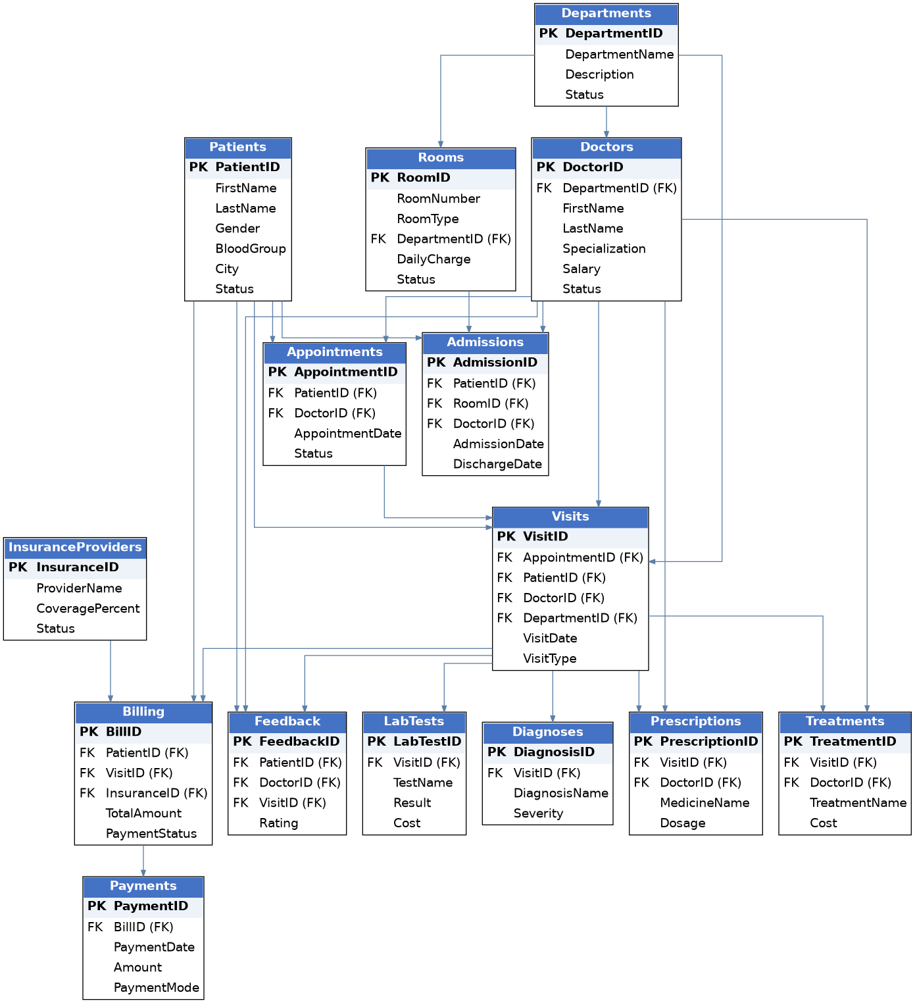

BASIC LEVEL
• List the first name, last name, and email of every patient.
• Find all doctors whose salary is greater than 1,20,000.
• Find all visits that are of VisitType 'Emergency' AND belong to DepartmentID 4 (Neurology).
• List all doctors sorted by DepartmentID ascending, then LastName descending.
• Show the distinct list of cities where patients live.
• Show the 5 most recently hired doctors.
• Find all visits that took place between 1 Jan 2024 and 30 Jun 2024.
• Find all patients who live in Chennai, Coimbatore, or Madurai.
• Find all medicines whose name contains the word "cin".
• List all admissions that have not yet been discharged (DischargeDate is NULL).
• Count the total number of registered patients.
• Find the average, minimum, and maximum doctor salary.
• Show each doctor's annual salary (Salary x 12) as AnnualSalary.
• List each visit's chief complaint along with the department name it belongs to.
• Deactivate patient PatientID = 12, and delete the dummy feedback FeedbackID = 99999.
• Find the number of visits registered under each Department.
• Find doctors who are assigned more than 1 visit.
• Show VisitID, Patient full name, Doctor full name, and Department name for every visit.
• List every department with its doctor count, including departments with zero doctors.
• Retrieve the count of visits month-wise for the year 2024.

INTERMEDIATE LEVEL
• Find the top 5 doctors who generated the highest total revenue (via Treatments).
• Retrieve patients who have visits registered under multiple departments.
• Find the department generating the maximum total billed revenue.
• Display patients who filed (visited for) more than 1 visit.
• Find the most frequently used payment mode across the system.
• Retrieve doctors whose average feedback rating is above 4.0.
• Retrieve the department with the second highest number of visits.
• Find patients whose visits are mostly of type 'Emergency'.
• Retrieve the average length of hospital stay (in days) per department.
• Find the top 5 cities generating the maximum number of patients.
• Display lab tests that are linked to more than 2 different visits.
• Find patients who never provided feedback after a completed visit.
• Retrieve all duplicate patient records based on name and phone number.
• Find the percentage contribution of each doctor to total revenue collected.
• Find the percentage contribution of each department to total revenue billed.
• Display doctor performance rank using: Total visits handled, Total revenue generated, Average feedback rating.
• Find departments whose average revenue per visit exceeds the overall average revenue per visit.
• List all Critical severity diagnoses that are still ongoing, with patient, doctor, and department.
• Show the number of visits per VisitType per Department.
• Create a view that shows visit ID, patient name, doctor name, department, and visit status.

ADVANCED SQL (WINDOW FUNCTIONS, CTEs, STORED PROCEDURES, TRIGGERS)
• Rank doctors within each department by total revenue generated (RANK window function).
• Each patient's single most recent visit (ROW_NUMBER dedup pattern).
• Running total of revenue billed per day (window function).
• Month-over-month revenue trend with previous month comparison (LAG).
• Top 5 revenue-generating departments (CTE).
• Doctors handling more visits than every doctor in "General Medicine" (ALL).
• Department-wise visit type report (pivot-style conditional aggregation).

Stored Procedure — Patient Visit History
Retrieves the full visit history for a given patient, most recent first.
DELIMITER $$

CREATE PROCEDURE GetPatientVisitHistory(IN p_PatientID INT)
BEGIN
SELECT v.VisitID, v.VisitDate, CONCAT(doc.FirstName,' ',doc.LastName) AS DoctorName,
d.DepartmentName, v.ChiefComplaint, v.Status
FROM Visits v
JOIN Doctors doc ON v.DoctorID = doc.DoctorID
JOIN Departments d ON v.DepartmentID = d.DepartmentID
WHERE v.PatientID = p_PatientID
ORDER BY v.VisitDate DESC;
END$$

DELIMITER ;

-- Usage: CALL GetPatientVisitHistory(1);

Trigger — Automatic Payment Status Update
Fires after every new payment and recalculates the paid amount and payment status on the related bill.
DELIMITER $$

CREATE TRIGGER trg_UpdatePaymentStatus
AFTER INSERT ON Payments
FOR EACH ROW
BEGIN
DECLARE v_TotalAmount DECIMAL(12,2);
DECLARE v_TotalPaid DECIMAL(12,2);

SELECT TotalAmount INTO v_TotalAmount FROM Billing WHERE BillID = NEW.BillID;
SELECT COALESCE(SUM(Amount),0) INTO v_TotalPaid FROM Payments WHERE BillID = NEW.BillID;

UPDATE Billing
SET PaidAmount = v_TotalPaid,
PaymentStatus = CASE
WHEN v_TotalPaid >= v_TotalAmount THEN 'Paid'
WHEN v_TotalPaid > 0 THEN 'Partially Paid'
ELSE 'Pending'
END
WHERE BillID = NEW.BillID;
END$$

DELIMITER ;

Stored Procedure — Safe Bed Admission Booking
Admits a patient to a room only if that room is currently available, and marks the room Occupied inside the same transaction to prevent double-booking.
DROP PROCEDURE IF EXISTS AdmitPatient;
DELIMITER $$

CREATE PROCEDURE AdmitPatient(
IN p_PatientID INT,
IN p_RoomID INT,
IN p_DoctorID INT
)
BEGIN
DECLARE roomStatus VARCHAR(20);

SELECT Status INTO roomStatus FROM Rooms WHERE RoomID = p_RoomID;

IF roomStatus IS NULL THEN
SIGNAL SQLSTATE '45000'
SET MESSAGE_TEXT = 'Room Not Found';
ELSEIF roomStatus = 'Available' THEN
START TRANSACTION;
INSERT INTO Admissions (PatientID, RoomID, DoctorID, AdmissionDate, Status)
VALUES (p_PatientID, p_RoomID, p_DoctorID, NOW(), 'Admitted');
UPDATE Rooms SET Status = 'Occupied' WHERE RoomID = p_RoomID;
COMMIT;
ELSE
SIGNAL SQLSTATE '45000'
SET MESSAGE_TEXT = 'Prohibited: Room Not Available';
END IF;
END$$

DELIMITER ;

-- Usage: CALL AdmitPatient(2, 9, 6);

